Action Bladder Cancer UK   
6 Trull Farm Buildings  
Tetbury GL8 8SQ

T: 0300 302 0085

28.03.2025

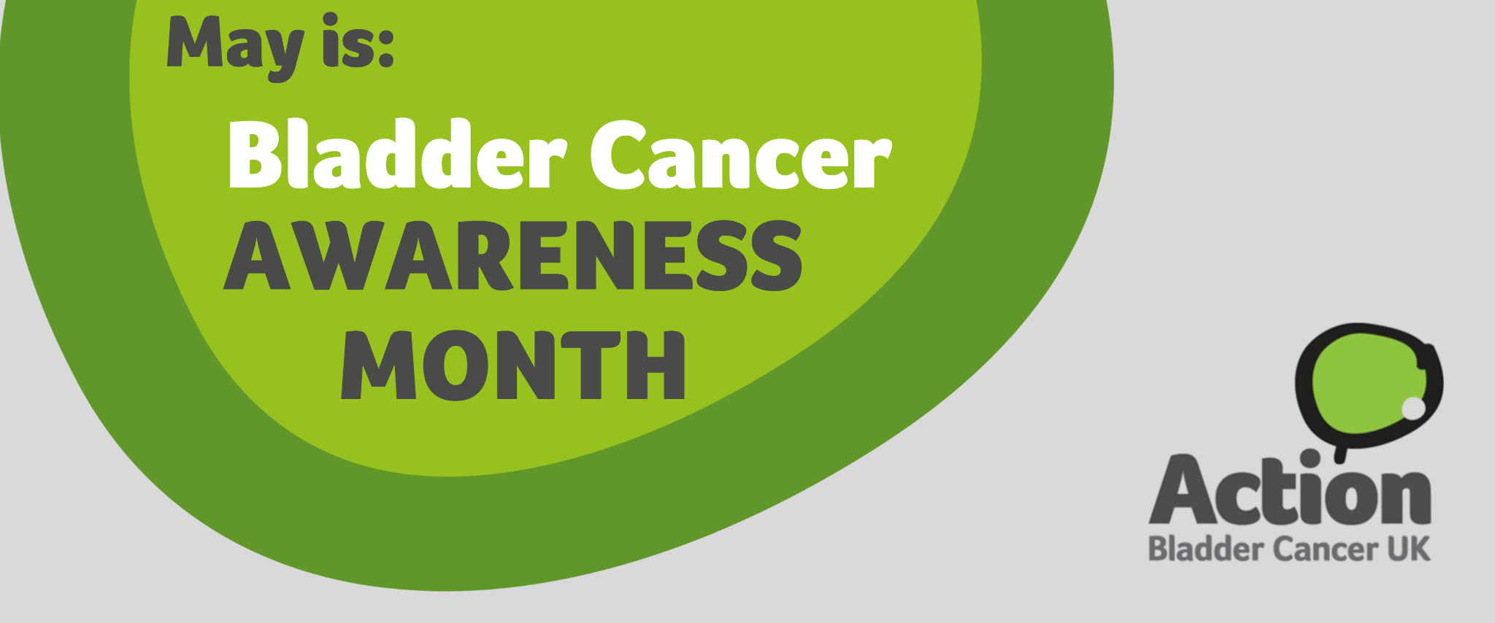

**Action Bladder Cancer UK Urges Health Professionals to Help Raise Awareness During Bladder Cancer Awareness Month**

[Action Bladder Cancer UK](https://actionbladdercanceruk.org) is calling on specialist urology and cancer nurses, as well as other health professionals, to support May’s Bladder Cancer Awareness Month by helping to raise awareness of the [symptoms of bladder cancer](https://actionbladdercanceruk.org/symptoms/) and of the vital work of ABC UK.

In the UK, over 20,000 people are diagnosed with bladder cancer each year, yet it is still not widely recognised as a common cancer. The main symptoms include blood in the urine (even if only once); the persistent or recurrent need to pass urine more often or more urgently; and pain or discomfort in the pelvic area. Action Bladder Cancer UK is encouraging health professionals to actively promote awareness of bladder cancer symptoms, helping more people recognise the signs and seek timely medical advice.

Health professionals can contribute by running awareness stands, requesting their workplaces to share information online for staff and the public, promoting awareness through social media, helping to spread the word about ABC UK to their patients, or organising fundraising events. Action Bladder Cancer UK offers a variety of free resources to support initiatives, including printed materials, pens, lanyards, badges, T-shirts, social media assets, and more.

Jeannie Rigby, Action Bladder Cancer UK CEO says: “Recognising the symptoms of bladder cancer is key to early diagnosis. Unfortunately, some cases can be diagnosed late, leading to worse outcomes. Bladder cancer can be overlooked, particularly in women, where symptoms can be confused as urinary tract infections or gynaecological issues. It's important to never ignore blood in your urine. Be aware of the signs, and visit your GP if you have any concerns”.

For further information on how you can [get involved](https://actionbladdercanceruk.org/get-involved/) in Bladder Cancer Awareness Month and support ABC UK, [order your resources and merchandise](https://actionbladdercanceruk.org/order-materials/) or download shareable [social media assets](https://actionbladdercanceruk.org/awareness-month/), visit the website or email [info@actionbladdercanceruk.org](mailto:info@bladdercanceruk.org).

For more information about Action Bladder Cancer UK and our work visit [www.actionbladdercanceruk.org](http://www.actionbladdercanceruk.org).

--------------------------------------------------- ENDS-----------------------------------------------

About Action Bladder Cancer UK:

ABC UK’s mission is to support bladder cancer patients and their families, raise awareness of the disease to improve early diagnosis and outcomes, and support research into bladder cancer.

**For media inquiries, please contact:**

Press enquiries -

E: info@actionbladdercanceruk.org

T: 0300 302 0085

W: www.actionbladdercanceruk.org

Registered charity: 1164374